

**Swap-O-Meal**

Requirements and Design Document:

CHIRAG JAIN

801026633

cjain3@uncc.edu

Project Overview –

Swap-o-Meal is an application for a person to enjoy various delicacies from all around the world without visiting high-end and costly restaurants or craving for a ‘Moroccan’ food joint in your city.

The application enables the users to take the advantage of Barter system in the area of Meals/Food/delicacies. It allows people to come together and share what Meal they have and swap it with the one meal which they would like to try/eat. It is a unique way of enjoying many different food items without the involvement of any money-based transaction between anyone.

The application will be having two ways of viewing, the guest user access to the application which will only have limited functions. For swapping a meal with someone you need to have an account and an available meal with you, ready to be swapped with someone who has another meal and interests you as well. This is a simple method, where both the two parties come and accepts each other’s’ offers of swapping their meals. It works only when both the sides choose to accept the offer.

The target market is any individual who has a taste bud ready to explore and continuously taste new delicacies from all the parts of the world. The user can be of any age but should be located in the near vicinity of the other users. Or say, the application is useful only to users in a common area.

Site – map

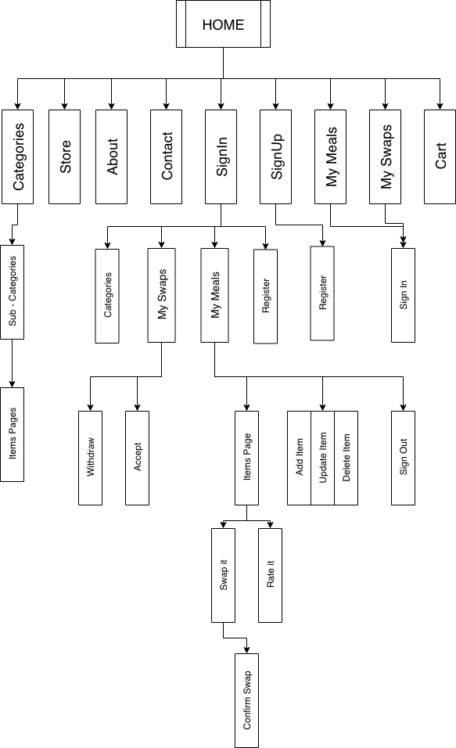

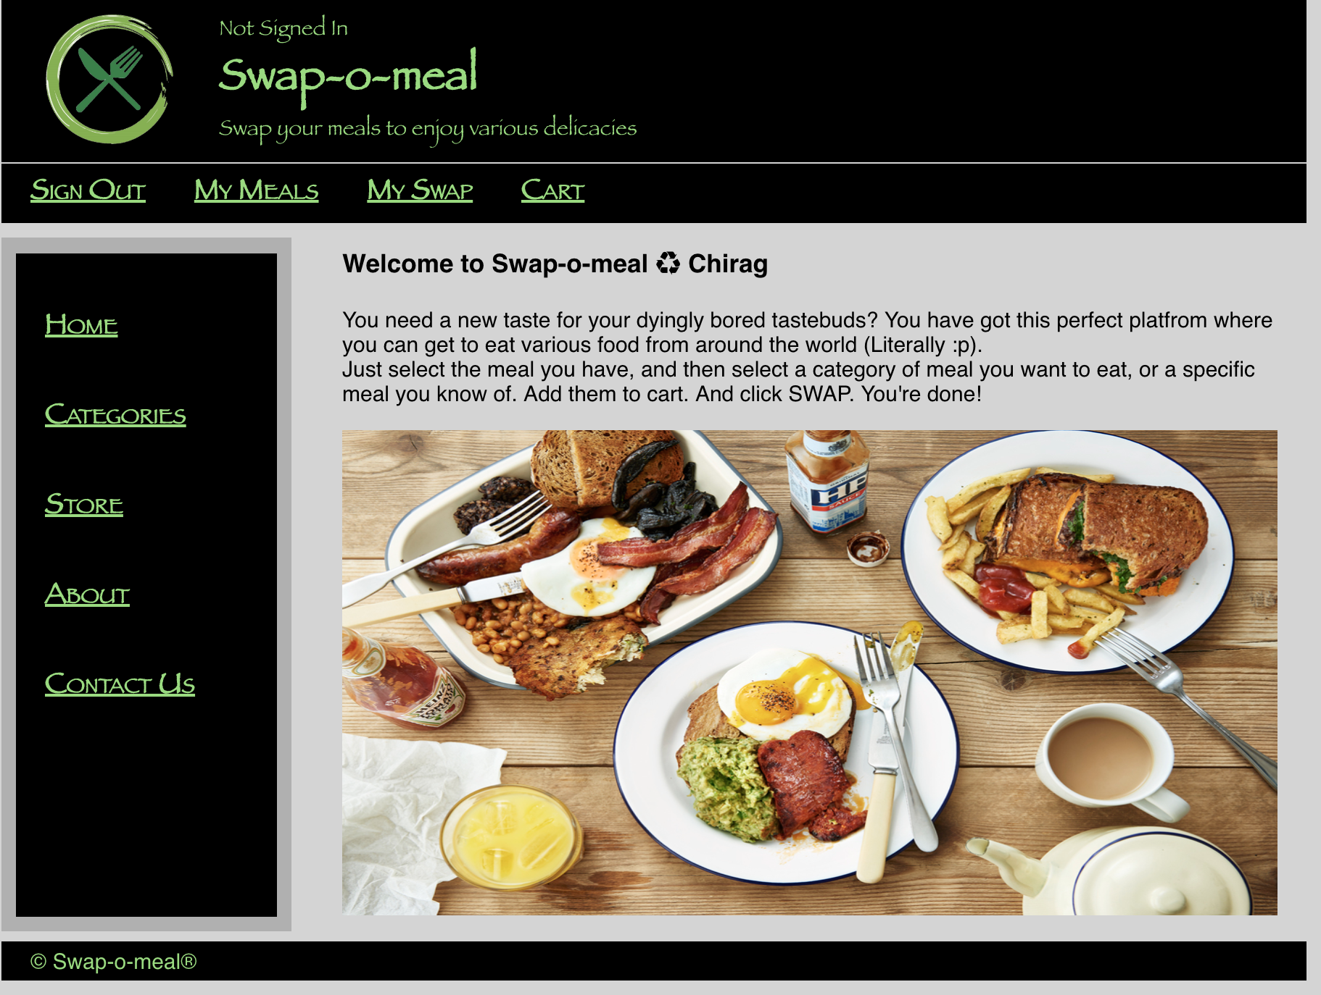

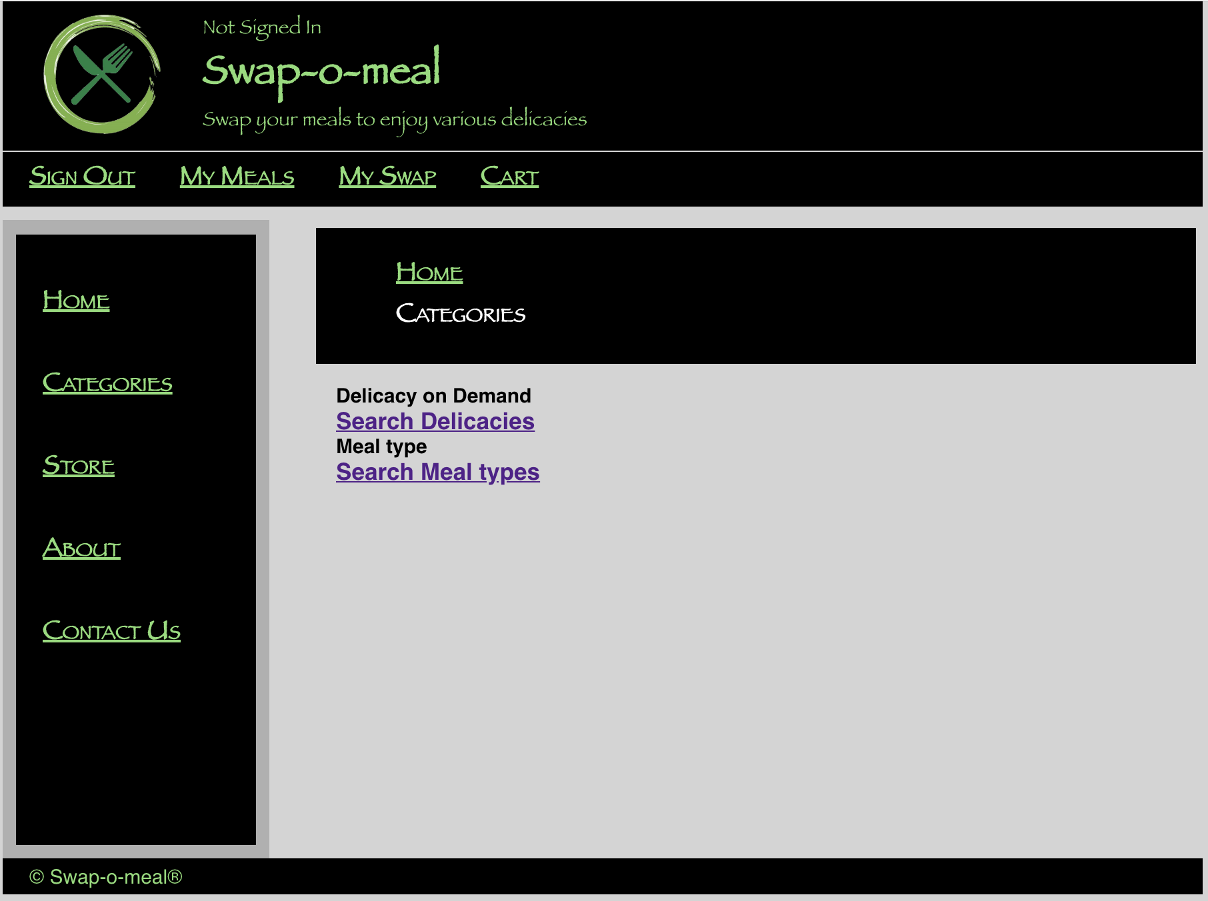

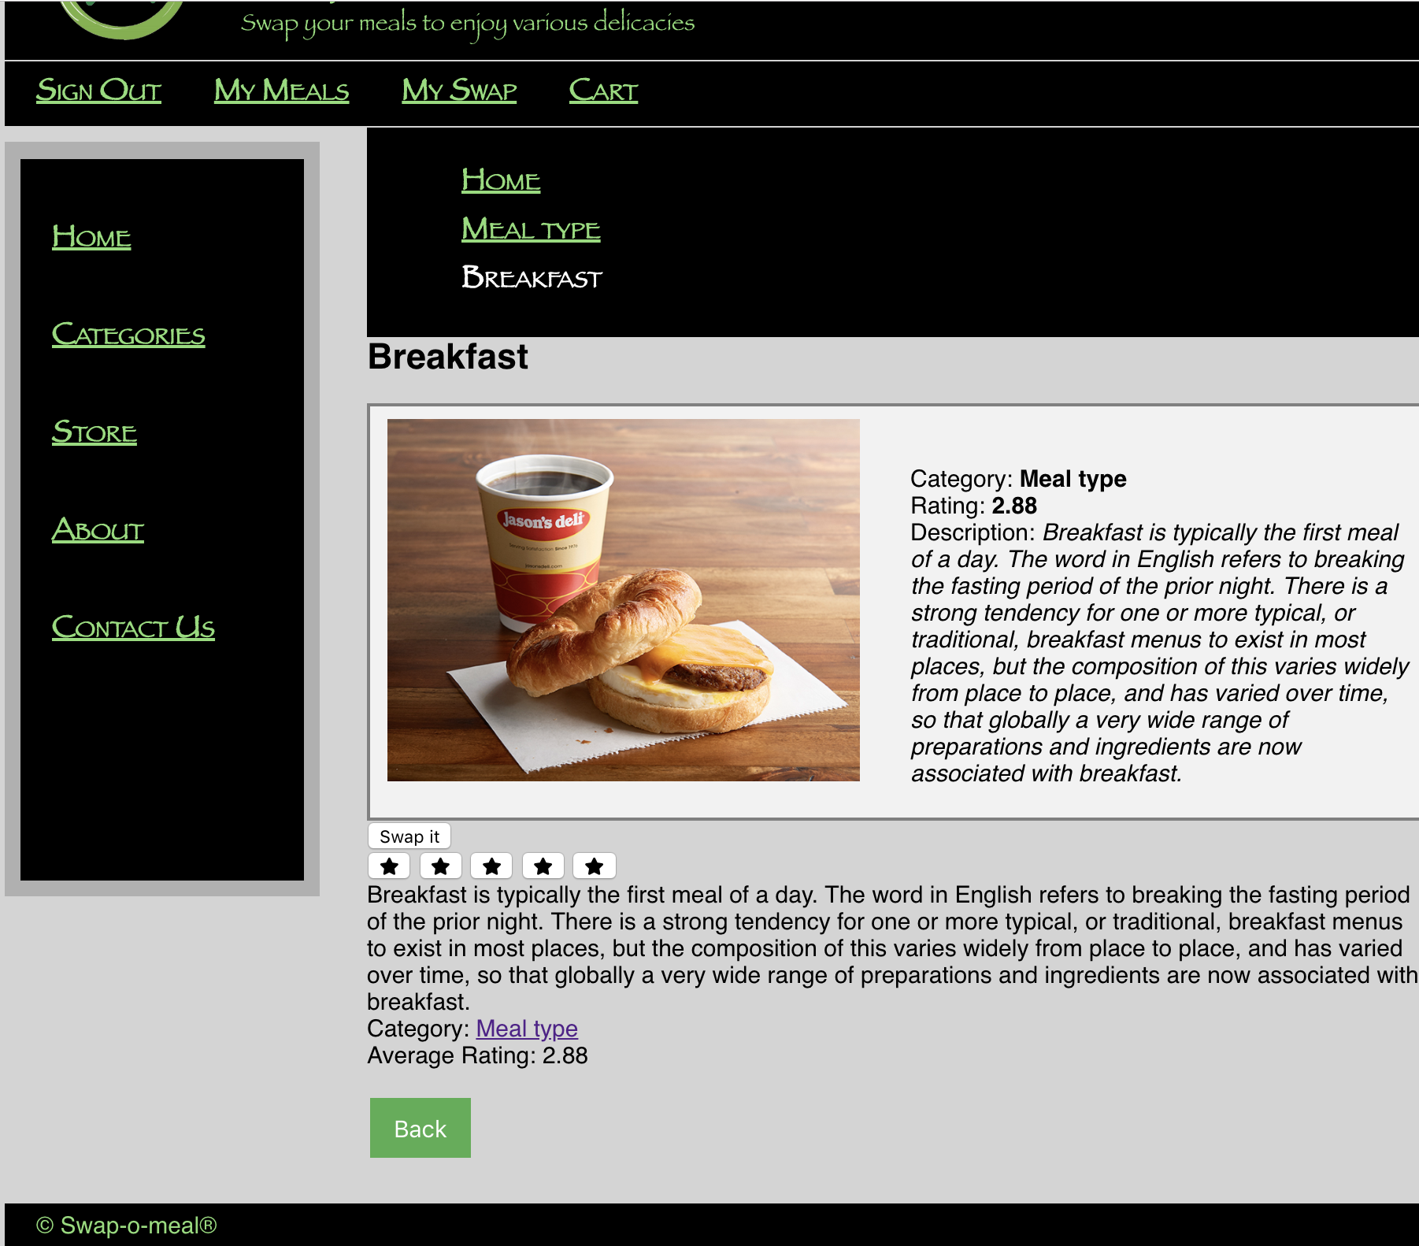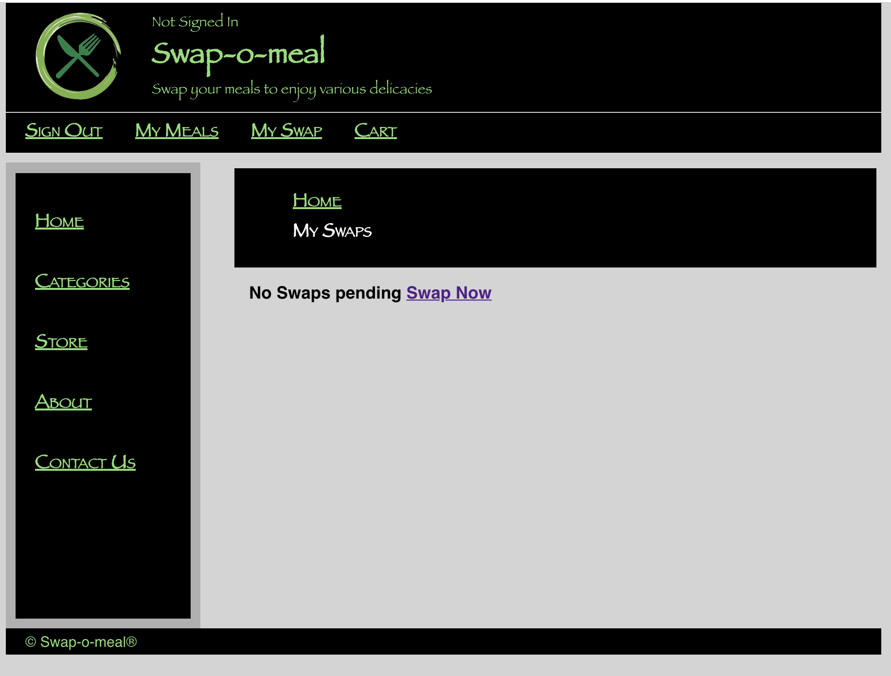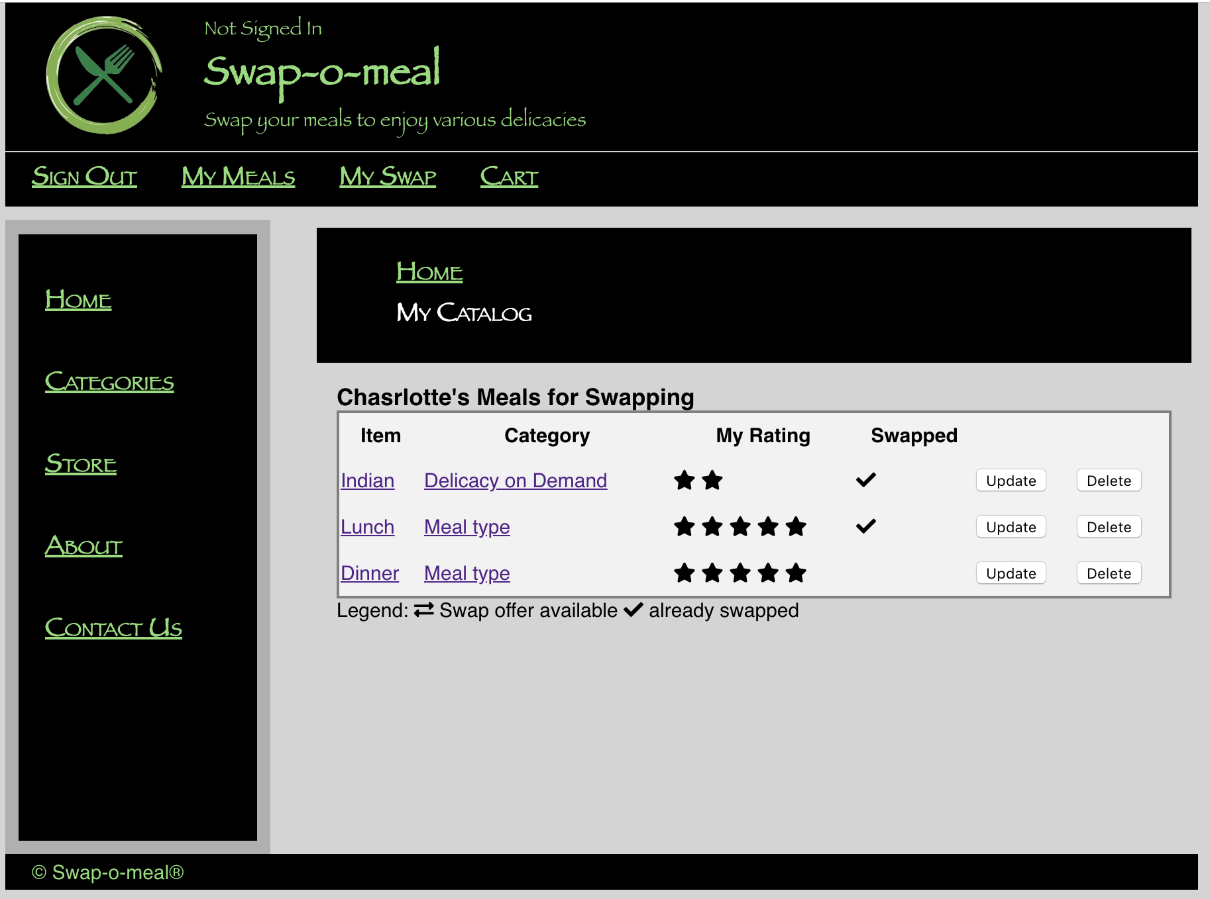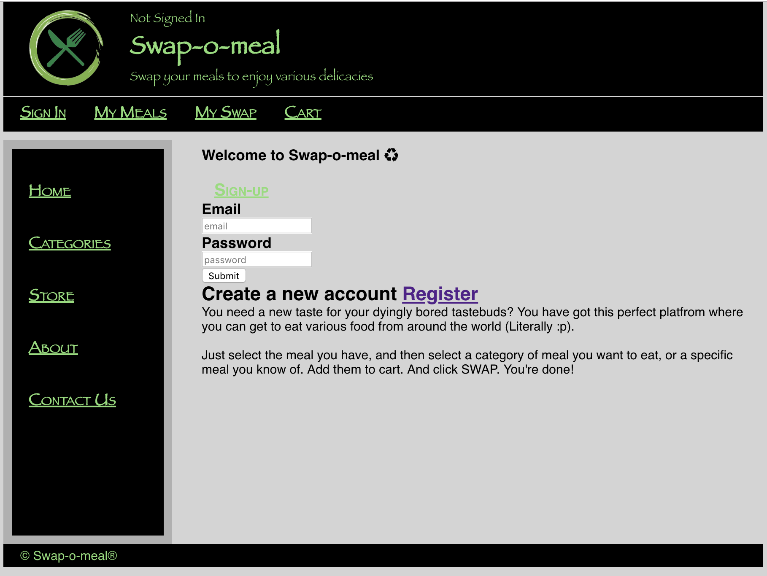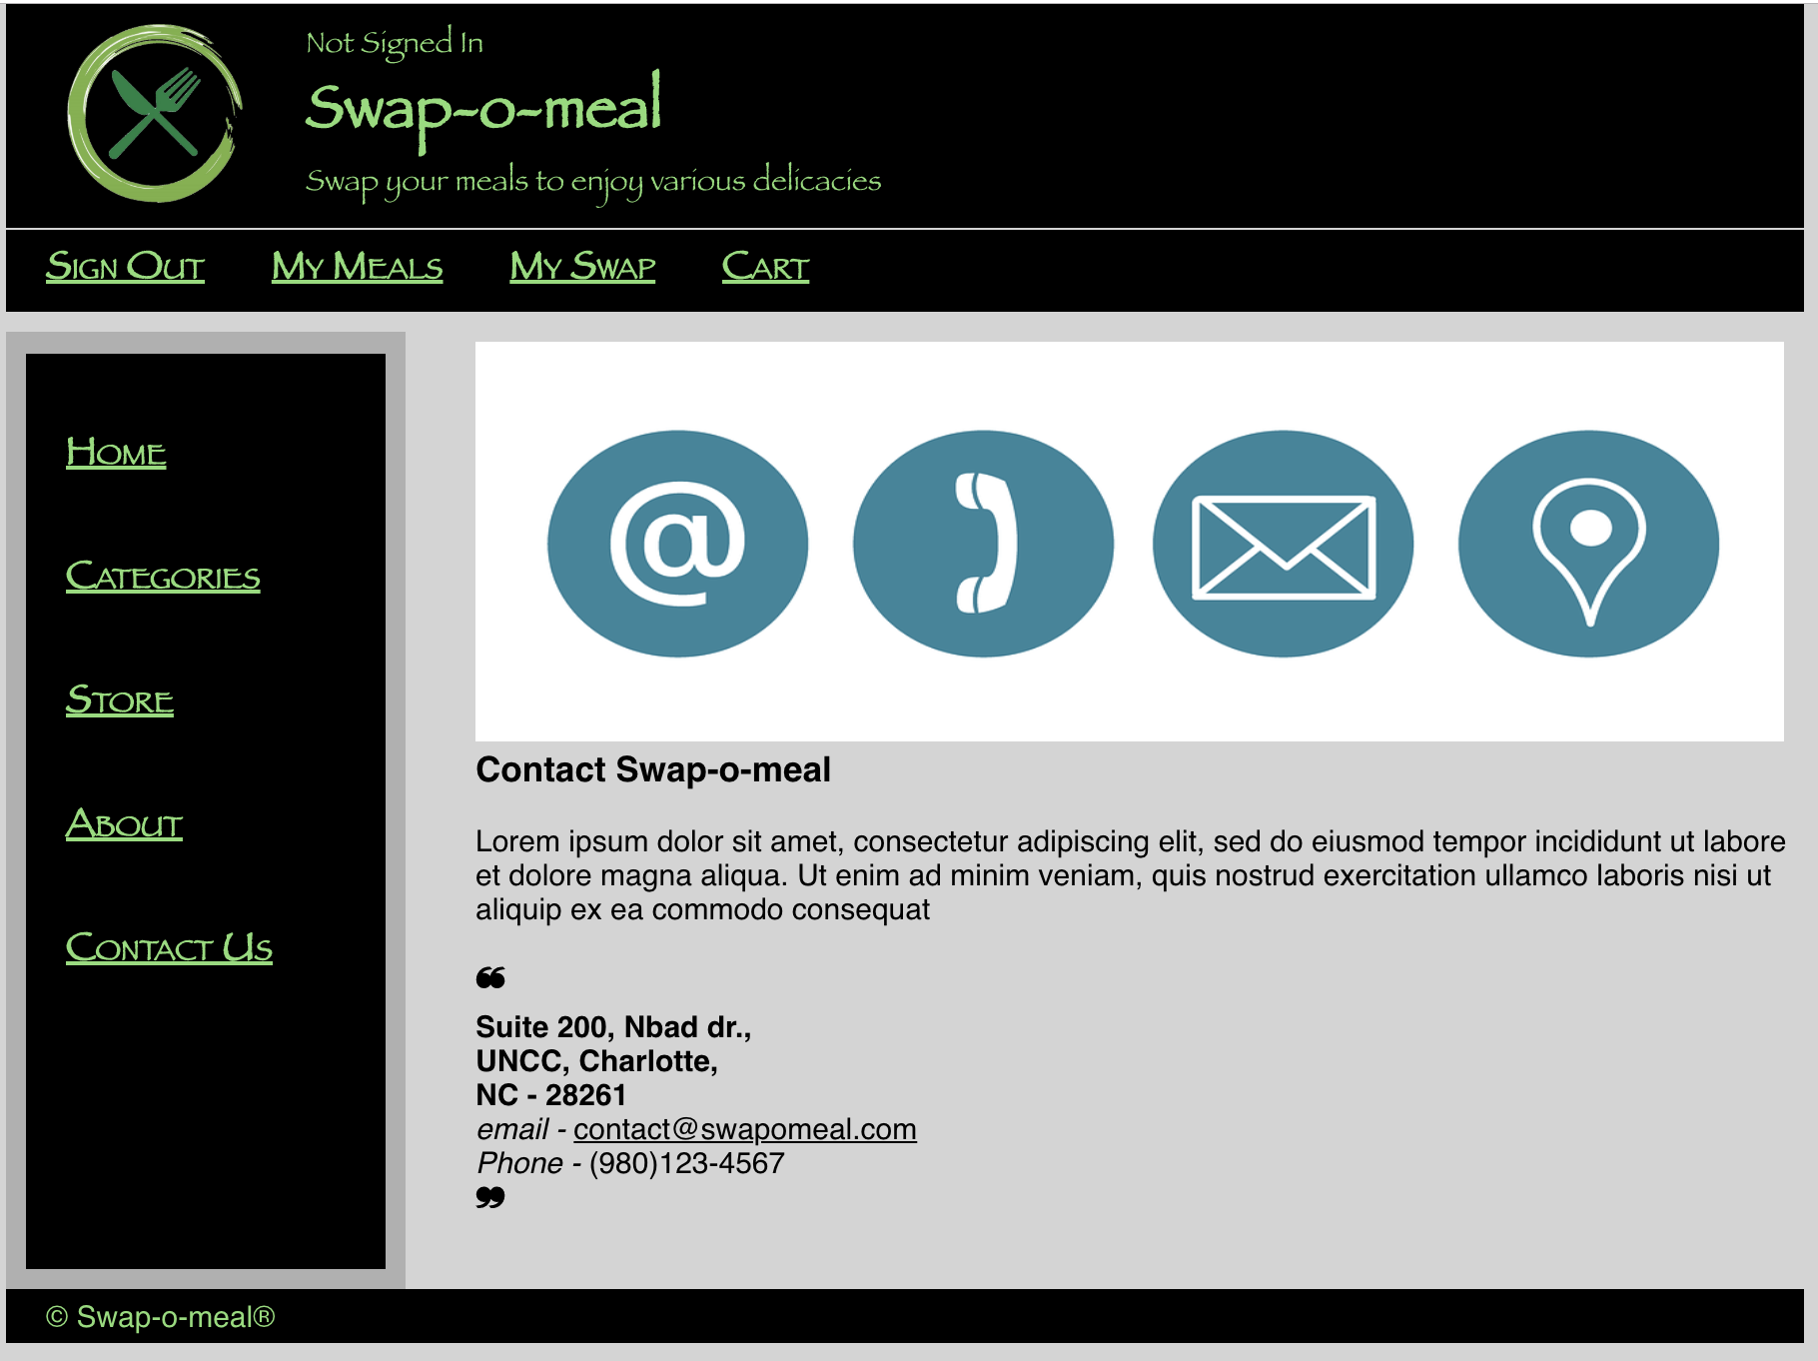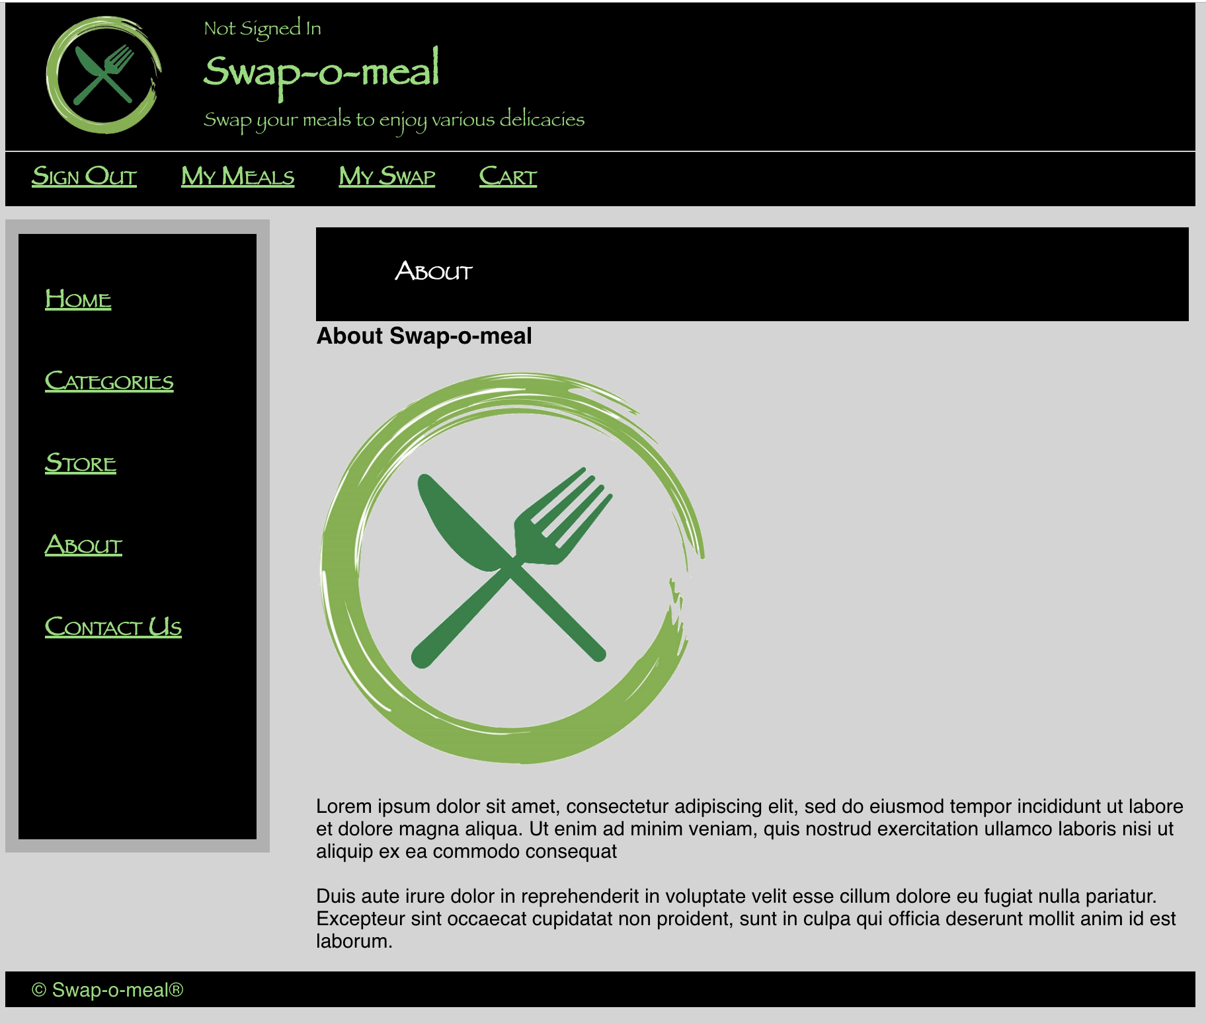

|  |  |  |  |  |
| --- | --- | --- | --- | --- |
| **users** | **items** | **offers** | **itemfeedbacks** | **userfeedbacks** |
| userId | userId | offerId | feedbackId | feedbackId |
| password | code | userId | userId | userId |
| salt | name | swapUserId | itemCode | ratedUserId |
| firstName | category | userItemCode | rating | rating |
| lastName | description | swapUserItemCode | feedback | feedback |
| email | rating | status | - | - |
| addressField1 | totalUserRatedItem | - | - | - |
| addressField2 | totalUserRating | - | - | - |
| city | image_url | - | - | - |
| state | active | - | - | - |
| zip | userRating | - | - | - |
| country | status | - | - | - |